**Lab 7 – Input Types**

**Lab 7-1**

Write an HTML form for inputting the **HKID No** with value checking.

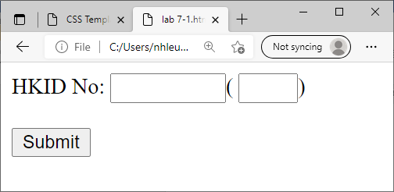

**Lab 7-2**

Write an HTML input form same as below.

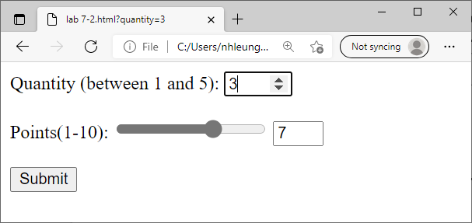

**Lab 7-3**

Write an HTML input form same as below.

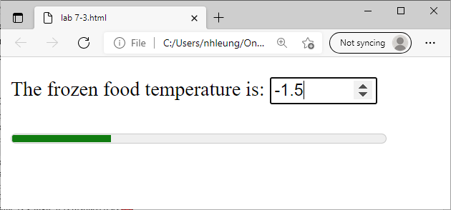

Number textbox properties: min = -50, max = 50, step = 0.5, only digits for input.

Meter properties: min = -50, max = 50, optimum = -10, low = 0, high = 30.

**Lab 7-4**

Write an HTML input form same as below.

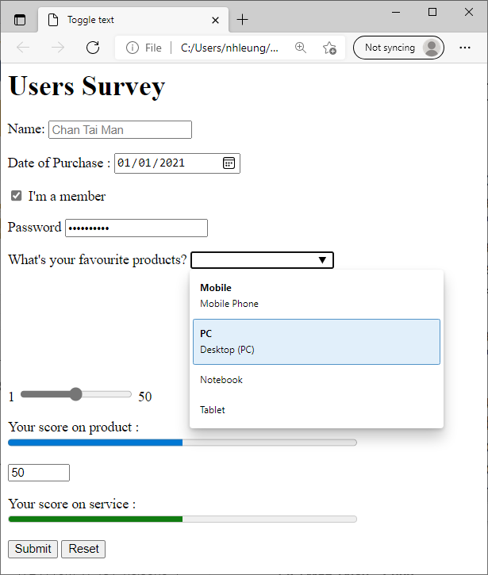

Notes:

1. The slider can control the progress bar which has max value of 50.
2. The number textbox can control the meter bar. The range of the number is 0-100 with low=40, high=75, optimum=65.
3. **Use jQuery to implement the animation of progress bar and meter.**

**Lab 7-5**

The following HTML5 page could calculate the weighted module marks of a student. Each component is assigned a weighting **2**, **3** or **5** by choosing an item from the datalist as shown in **Fig 1**. (Assume the weightings of different components cannot be the same.)

The actual component marks are inputted in the textboxes beside the datalist.

E.g. the weighted marks of **Fig 2** are calculated as (2 * 70 + 3 * 60 + 5 * 86) / 10 = 75

The meter’s color: Red if marks < 40 and Green if marks >=75; otherwise, Yellow.

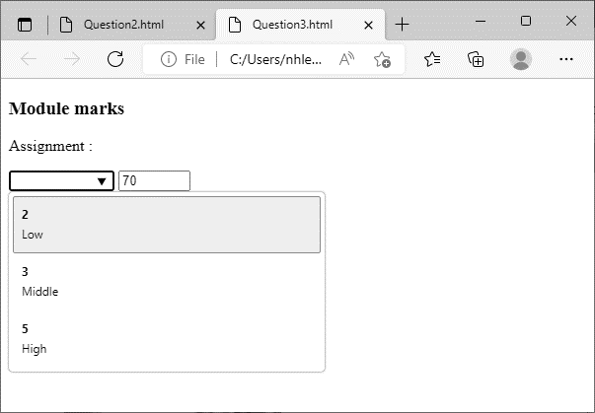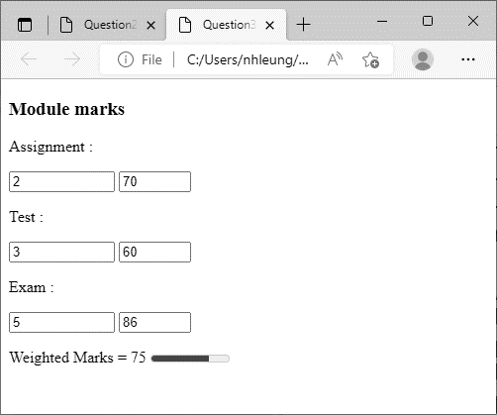

Weighting

Actual marks

**Fig 1 Fig 2**